**Lab 5 - Animation**

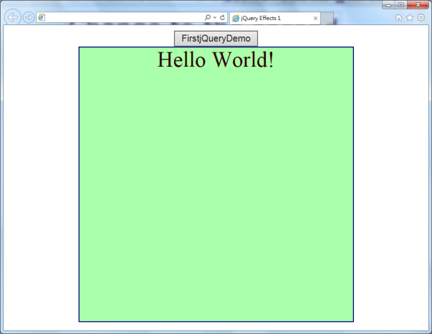**Lab 5-1**

Write a jQuery program to do the following animation:

When the button “FirstjQueryDemo” is clicked, a square appears below the button and then expands to a large square as shown in the figure.

**Lab 5-2**

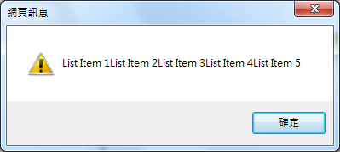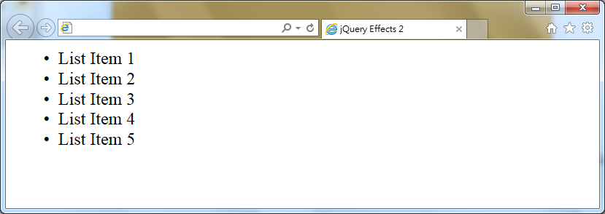Write a jQuery program to show 5 items in the browser, When the program is run a message box as show in the figure is displayed.

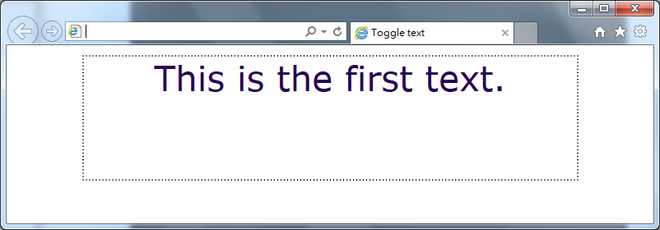**Lab 5-3**

Write a jQuery program to display the message “This is the first text.” as shown in the figure. When the phrase is clicked, another message is displayed : “Change to the second text”.

**Lab 5-4**

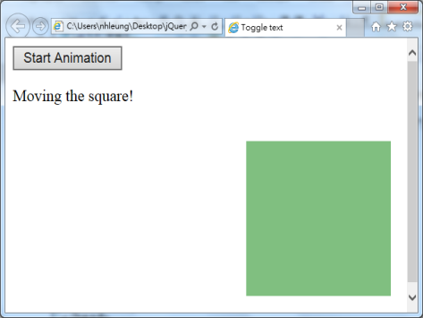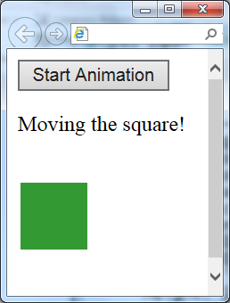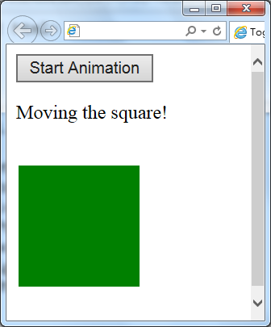

🡺 🡺

Write a jQuery program to do the above animation. At the beginning, the layout is the same as the left figure. When the button is clicked, the square starts to change/move to the middle one within 2 seconds. Finally, it will change to the right figure within 3 seconds.

<body> of the original figure:

<button>Start Animation</button>

<p>Moving the square!</p>

<div style="background:green;

left:10px; top:100px;

height:100px;width:100px;

position:absolute;">

</div>

**Lab 5-5**

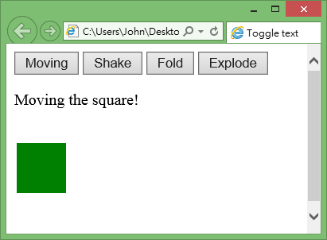Write a program to show the layout in the right.

Functions of the buttons when clicked:

Moving: The green box moveｓ to the right-bottom and then go back to the original position after 3 seconds. Then an message “Finished” is displayed.

Shake: The green box shakes for 2 seconds.

Fold: The green box folds up within 2 seconds.

Explode: The green box explodes for 3 seconds.

Hints: Use the jquery file **jquery-ui.js**

**Lab 5-6**

Beginning: After animation:

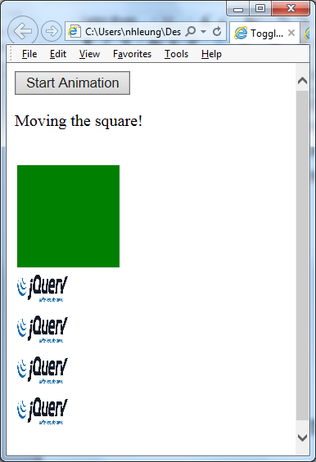

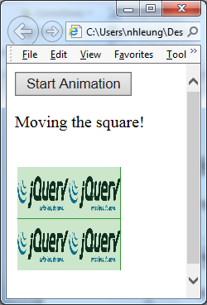

In addition to the layout of Lab 5-5, four jQuery logos are placed under the green box as shown in the figure above. Height and width of the logos are 50 x 50 px.

When the button Start Animation is clicked, the four logos start animation similar to the green box as in Lab 5-5.

At the end, the four logos stop on the green box as seen in the figure above.

The green box does not move throughout the animation.